

Topic test 1
Name: __________________________________

Chapter 1: Equations and polynomials

- Time allowed: 45 minutes
- CAS calculators may be used.
- Part A: 5 multiple-choice questions (5 marks)
- Part B: 6 short answer questions (32 marks)
- Part C: 3 analysis questions (23 marks)
Part A
5 multiple-choice questions
1 mark each: 5 marks
Circle the correct answer.
1 One or more errors have been made in the solution to this linear equation. State where the error(s) occurred.
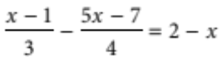
4(x − 1) − 3(5x − 7) = 2 − x Line 1
4x − 4 − 15x − 21 = 2 − x Line 2
−11x − 25 = 2 − x Line 3
−10x = 27
x = −2.7
A Line 1 only.
B Line 2 only.
C Line 3 only.
D Line 1 and Line 2.
E Line 1, Line 2 and Line 3.

[1 mark]

2 Solve the equation 2x² + 7x − 3 = 0, for x correct to 2 decimal places.
A x = −3.89 and 0.39
B x = −0.5 and −3
C x = −0.77 and −7.72
D x = 0.39 and 3.89
E x = 0.77 and 7.72

[1 mark]
3 Given that y is inversely proportional to the square of x, and that y = 8 when x = 3, find the value of x when
y = 128.
A 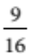
B
C 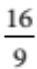
D
E 12

[1 mark]
4 Solve the equations 8a + b = −12 and 4a − 3b = −20 simultaneously.
A a = 2, b = −28
B a = −3.5, b = 16
C 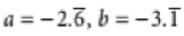
D a = 2, b = −28
E a = −2, b = 4

[1 mark]

5 Factorise x³ − 5x² − 12x + 36.
A (x + 2)(x − 3)(x + 6)
B (x − 2)(x − 3)(x + 6)
C (x − 2)(x + 3)(x − 6)
D (x + 2)(x − 3)(x − 6)
E (x − 2)(x − 3)(x − 6)

[1 mark]
Part B
6 short answer questions
32 marks
Show your working where appropriate.
1 Solve the following equations.
a 2 + 5(m − 1) = 5m − (m − 15)

b 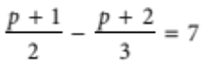

[5 marks]
2 Solve the following equations.
a (x − 4)(2x + 13) = 0

b x² + 6x − 12 = 0 (by completing the square)

c 2x² − 3x − 5 = 0 (by factorisation)

d x² + 6x − 1 = 0 (using the quadratic formula)

[10 marks]
3 Solve the equations 3x − y + 5 = 0 and y = 5x − 11.

[4 marks]
4 The amount of fuel used by a car is directly proportional to the distance travelled. On a trip of 810 km, a family car used 60 litres of fuel. How far could the car travel on 76 litres of fuel?

[3 marks]
5 Given that P(x) = 5x³ + x² − 7x + 4, find:
a the degree of the polynomial _________________________________________________________
b the leading term _________________________________________________________
c the constant _________________________________________________________
d the coefficients _________________________________________________________
e the value of P(−2).

[5 marks]

6 Divide the polynomial P(x) = 5x³ + x² − 7x + 4 by x + 2 and hence write P(x) in the form
P(x) = (x + 2)Q(x) + R.

[5 marks]
Part C
3 analysis questions
23 marks
Show your working where appropriate.
1 A ski tour operator offers complete packages from Melbourne to the Victorian snowfields. The tours may be from 3 to 12 days in length and they cost $700 for the 3-day tour and $160 for each additional day.
a Draw a graph showing the cost of the tours provided by this operator.

b Find a relationship between the number of days and the cost of the tours.

Another operator runs trips of any duration from 1 to 20 days with a flat rate of $190 per day.

c Draw a graph of the cost of the tours provided by this operator.
d Find a relationship between the number of days and the cost of the tours.

e State the circumstances under which each operator would be cheaper to use.

[12 marks]
2 Robyn and Jake go on a hiking trip. Robyn starts off carrying the pack with the tent and sleeping bags, and Jake starts with the one containing the food and cooking gear. After they have gone 15 km, they swap packs for a change and discover that Jake’s original pack is twice as heavy. They transfer 6 kg of food from Robyn’s new pack to Jake’s new pack, so that when they have completed the final 25 km of the hike, the total product of weight and distance will be the same for each person. Write an equation to find the original weight of each pack, then solve it to find the original weights.

[4 marks]

3 Solve 3x³ − 12x² + 3x + 18 = 0

[7 marks]
Total marks: 60

Answers
Part A [1 mark each]
1 Errors in Lines 1 and 2 are shown in red.
4(x − 1) − 3(5x − 7) = 12(2 − x) Line 1
4x − 4 − 15x + 21 = 2 − x Line 2
−11x − 25 = 2 − x Line 3
−10x = 27
x = −2.7
∴ D [1 mark]
2 2x² + 7x − 3 = 0
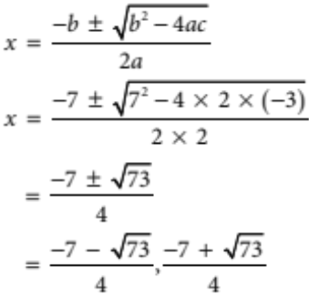
= −3.88600…, 0.38600…
≈ −3.89, 0.39 correct to 2 decimal places
∴ A [1 mark]
3 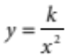
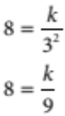
k = 72
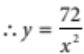
When y = 128
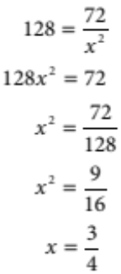
∴ B [1 mark]
4 8a + b = −12 [1]
4a − 3b = −20 [2]
[1] × 3 24a + 3b = −36 [1a]
[1a] + [2] 28a = −56
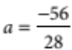
= −2
Substitute a = −2 into [1].
8 × (−2) + b = −12
−16 + b = −12
b = 4
∴ Solution is a = −2, b = 4
∴ E [1 mark]
5 x³ − 5x² − 12x + 36
P(2) = 2³ − 5(2)² − 12(2) + 36
= 0
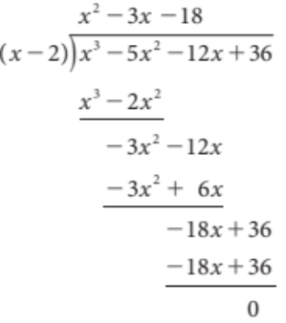
∴ (x − 2) is a factor
∴ x³ − 5x² − 12x + 36 = (x − 2)(x² − 3x − 18)
= (x − 2)(x + 3)(x − 6)
∴ C [1 mark]
Part B
1 a 2 + 5(m − 1) = 5m − (m − 15)
2 + 5m − 5 = 5m − m + 15
5m − 3 = 4m + 15 [1 mark]
m = 18 [1 mark]
b 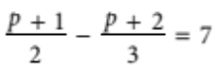 [1 mark]
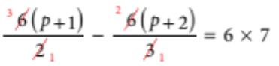
3(p + 1) − 2(p + 2) = 42
3p + 3 − 2p 2 4 = 42 [1 mark]
p − 1 = 42
p = 43 [1 mark]
2 a (x − 4)(2x + 13) = 0
x − 4 = 0 or 2x + 13 = 0
x = 4 or 2x = −13
x = −6.5
Solution: x = −6.5, 4 [1 mark]
b x² + 6x − 12 = 0
x² + 6x = 12
x² + 6x + 9 = 12 + 9 [1 mark]
(x + 3)² = 21 [1 mark]
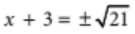
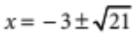 [1 mark]
c 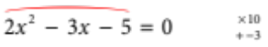
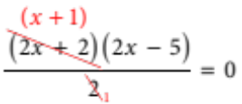 [1 mark]
(x + 1)(2x − 5) = 0
x + 1 = 0 or 2x − 5 = 0 [2 marks, 1 mark for each solution]
x = −1 or 2x = 5
x = 2.5
Solution: x = −1, 2.5
d x² + 6x − 1 = 0
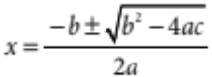 [1 mark]
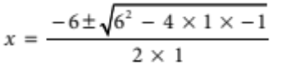 [1 mark]
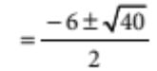 [1 mark]
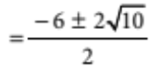
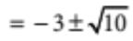 [1 mark]

3 3x − y + 5 = 0 [1]
y = 5x − 11 [2]
Substitute [2] into [1].
3x − (5x − 11) + 5 = 0 [1 mark]
3x − 5x + 11 + 5 = 0
−2x + 16 = 0
16 = 2x
x = 8 [1 mark]

Substitute x = 8 into [2]. [1 mark]
y = 5 × 8 − 11
y = 29 [1 mark]
Solution: x = 8, y = 29
4 The general equation for the amount of fuel used is: f = kd [1 mark]
When f = 60, d = 810
60 = 810k
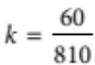
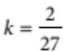 [1 mark]
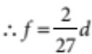
When f = 76, d = ?
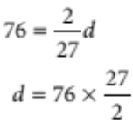
d = 1 026 [1 mark]
The car can travel 1026 km on 76 litres of fuel.
5 a The highest power of the polynomial is 3. [1 mark]
b The leading term contains the highest power, so it is 5x³. [1 mark]
c The constant has no pronumeral, i.e., the coefficient of x⁰, so it is 4. [1 mark]
d 5, 1, −7, 4
The numbers in front of the x terms in descending order of power. [1 mark]
e P(x) = 5x³ + x² − 7x + 4
P(−2) = 5(−2)³ + (−2)² − 7(−2) + 4
= 5 × (−8) + 4 + 14 + 4
= −18 [1 mark]
6 P(x) = 5x³ + x² − 7x + 4
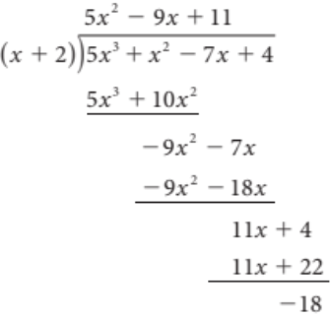

∴ 5x³ + x² − 7x + 4 = (x + 2)(5x² − 9x + 11) − 18 [1 mark]

Part C
1 a 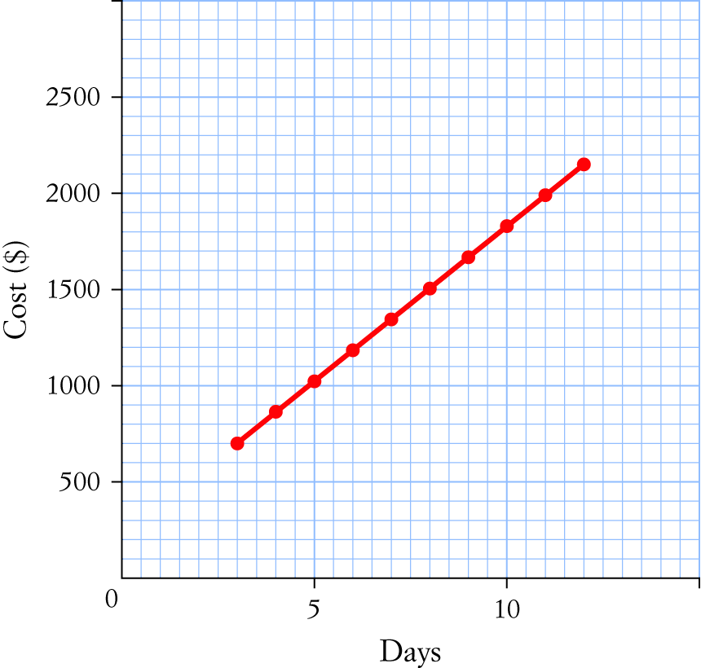
[2 marks for graph —1 for axes and labelling, 1 for correct linear graph]
Days | 3 | 4 | 5 | 6 | 7 | 8 | 9 | 10 | 11 | 12
Cost | 700 | 860 | 1020 | 1180 | 1340 | 1500 | 1660 | 1820 | 1980 | 2140
[1 mark]
b Cost of 3 days at $160 per day = $480
But 3 days cost $700, i.e., $480 + $220 [1 mark]
∴ Cost of 3 days = $160 × 3 + $220
Cost of tour = 160d + 220 [1 mark]
c
Days | 1 | 2 | 3 | 4 | 5 | 6 | 7 | 8 | 9 | 10
Cost | 190 | 380 | 570 | 760 | 950 | 1140 | 1330 | 1520 | 1710 | 1900
[1 mark]
Days | 11 | 12 | 13 | 14 | 15 | 16 | 17 | 18 | 19 | 20
Cost | 2090 | 2280 | 2470 | 2660 | 2850 | 3040 | 3230 | 3420 | 3610 | 3800

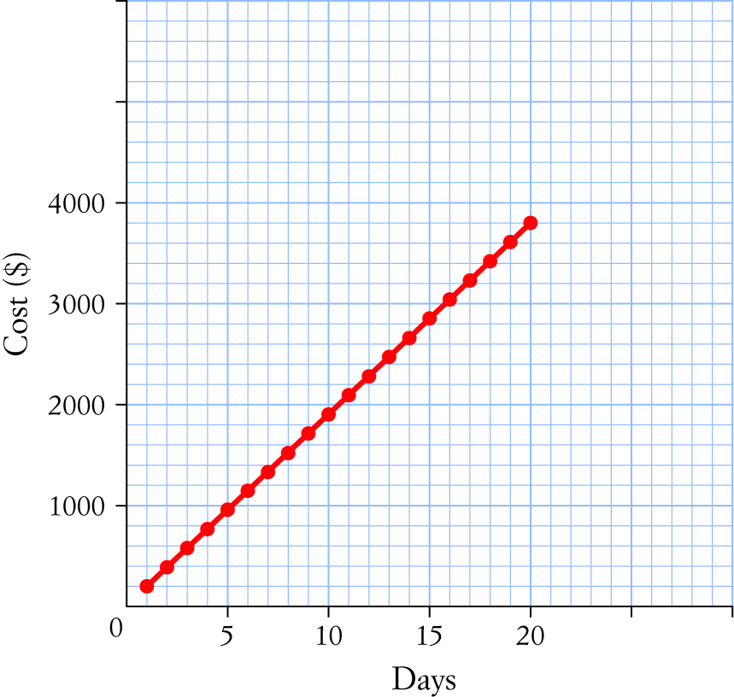
[2 marks for graph —1 for axes and labelling, 1 for correct linear graph]
d The cost is $190 per day, i.e., Cost = $190 × number of days [1 mark]
C = 190d [1 mark]
e Looking at the two tables Day 8 is the first day that the second tour becomes more expensive
than the first tour. [1 mark]
For tours between 3 and 7 days, the second operator is cheaper. For tours between 8 and 12 days,
the first operator is cheaper. [1 mark]
2 15s + 25(2s − 6) = 15 × 2s + 25(s + 6), where s is the weight of the pack that was originally
lighter; 30 kg and 60 kg
15s + 25(2s − 6) = 15 × 2s + 25(s + 6) [2 marks —1 for each side of the equation]
15s + 50s − 150 = 30s + 25s + 150
65s − 150 = 55s + 150
10s = 300
s = 30 [1 mark]
The heavier pack was twice the weight of the smaller pack.
∴ The original weight of the packs was 30 kg and 60 kg. [1 mark]
3 3x³ − 12x² + 3x + 18 = 0
3(x³ − 4x² + x + 6) = 0 [1 mark]
P(−1) = (−1)³ − 4(−1)² + (−1) + 6
= 0
∴ (x + 1) is a factor. [1 mark]
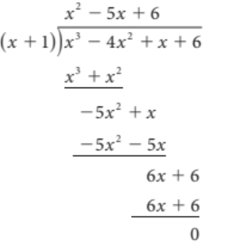
[2 marks for division working out, minus 1 for any mistake]

∴ 3(x + 1)(x² − 5x + 6) = 0 [1 mark]
3(x + 1)(x − 2)(x − 3) = 0 [1 mark]
x + 1 = 0 or x − 2 = 0 or x − 3 = 0 [1 mark]
x = −1 x = 2 x = 3
Solution: x = −1, 2, 3

Topic test 1

